Towers Game

Mlando Sikhosana Khoza

Contents

Towers Game 2

Link 2

Phase 1 – Understand Requirements 2

Betting Sequence 2

Easy Sequence 2

Medium Sequence 2

Hard Sequence 3

Proportionality 3

Sample 1: 8 - Easy 3

Sample 2: 8 – Easy 4

Sample 3: 8 - Easy 4

Sample 1: 8 – Medium 5

Sample 2: 8 – Medium 5

Sample 3: 8 – Medium 6

Sample 1: 8 – Hard 6

Sample 2: 8 – Hard 7

Sample 3: 8 – Hard 7

Conclusion 8

# Towers Game

## Link

[Full Screen Towers Game](https://static-live.hacksawgaming.com/1154/1.32.1/index.html?language=en&channel=desktop&gameid=1154&mode=2&token=123131&lobbyurl=https%3A%2F%2Fwww.hacksawgaming.com&currency=EUR&partner=demo&env=https://rgs-demo.hacksawgaming.com/api&realmoneyenv=https://rgs-demo.hacksawgaming.com/api)

## Phase 1 – Understand Requirements

BOXES is an exciting game where the objective is to find Diamonds by picking Boxes on different Rows. When you find a Diamond on a Row, you can advance to the next Row and increase your win! If you pick a Box containing a Mine, you will lose and have to restart the game. Before placing the bet, you can configure the game by choosing how many Rows you want and the Difficulty setting. A higher Difficulty means each Row will contain more Mines, but increases your potential winnings! Once you have placed your initial bet, each pick is free. Pick Boxes until you have reached the final Row, or are happy with the collectable win and wish to collect it.

## Betting Sequence

### Easy Sequence





|  |  |  |  |  |  |  |  |
| --- | --- | --- | --- | --- | --- | --- | --- |
| **1.76** | **2.82** | **3.95** | **5.92** | **9.87** | **13.17** | **19.75** | **39.51** |

### Medium Sequence





|  |  |  |  |  |  |  |  |
| --- | --- | --- | --- | --- | --- | --- | --- |
| **2.20** | **4.41** | **7.71** | **15.43** | **25.72** | **51.42** | **77.17** | **154.35** |

### Hard Sequence



|  |  |  |  |  |  |  |  |
| --- | --- | --- | --- | --- | --- | --- | --- |
| **2.94** | **7.84** | **18.29** | **36.58** | **91.46** | **182.93** | **274.40** | **548.80** |

I realised that the base amount is multiplied by the betting sequence. And the numbers are seemingly random but always stay the same. I couldn’t figure out the sequence.

## Proportionality

### Sample 1: 8 - Easy

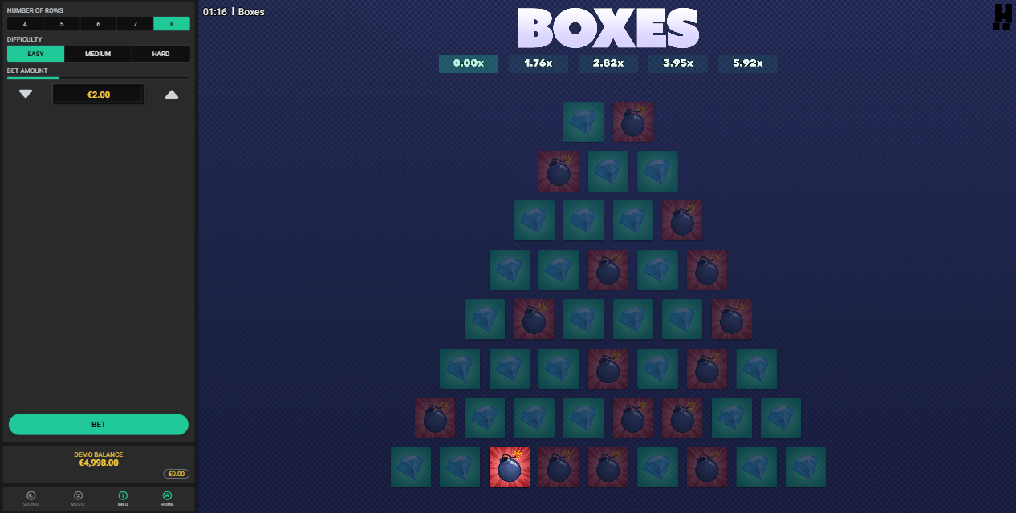

### Sample 2: 8 – Easy

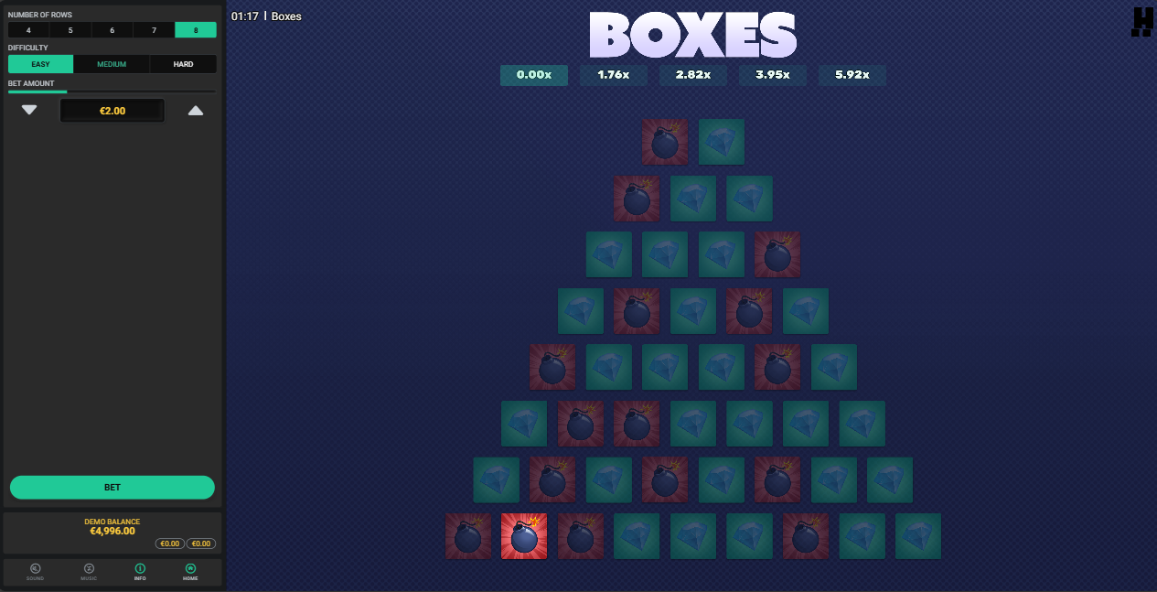

### Sample 3: 8 - Easy

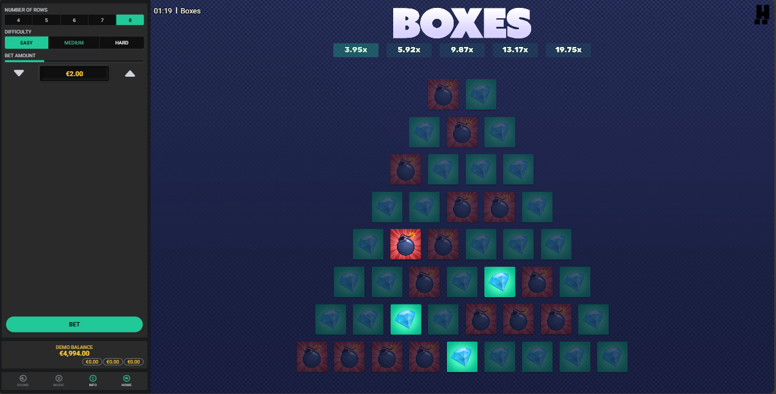

### Sample 1: 8 – Medium

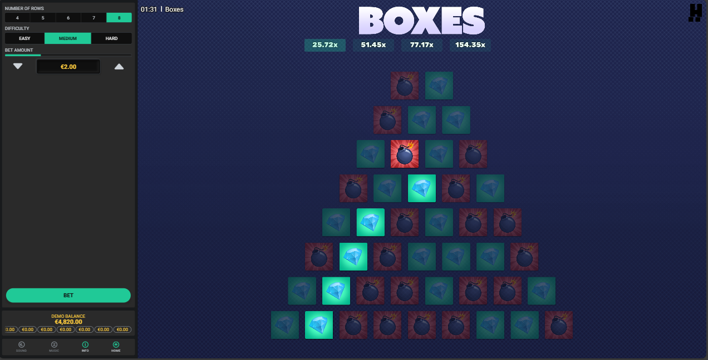

### Sample 2: 8 – Medium

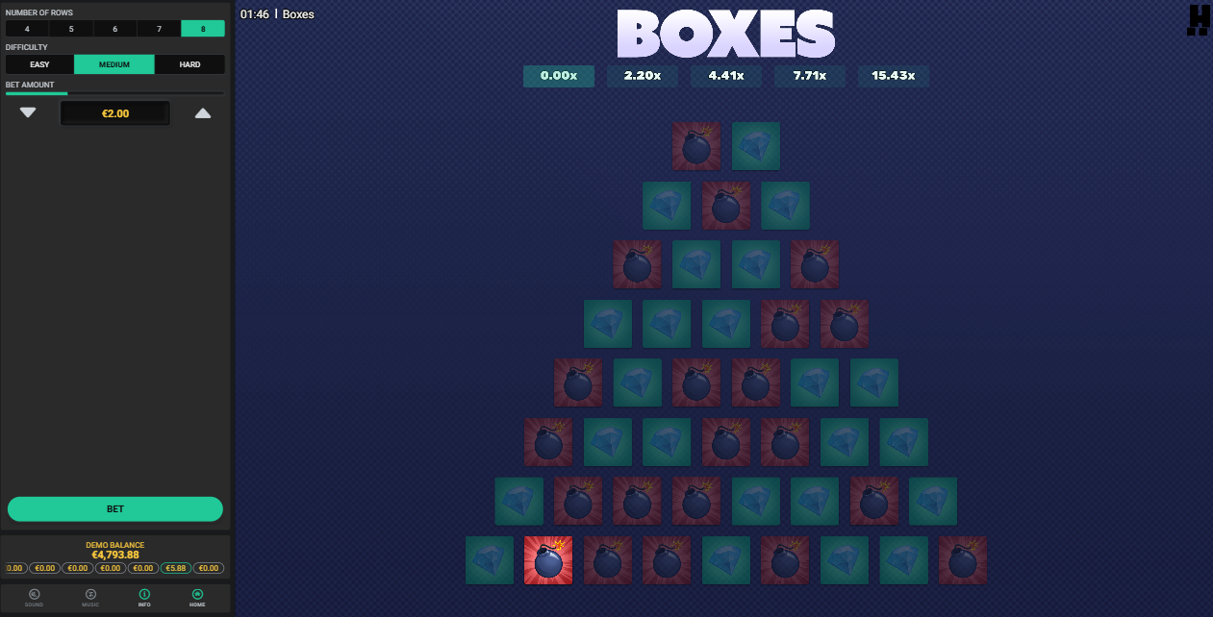

### Sample 3: 8 – Medium

### Sample 1: 8 – Hard

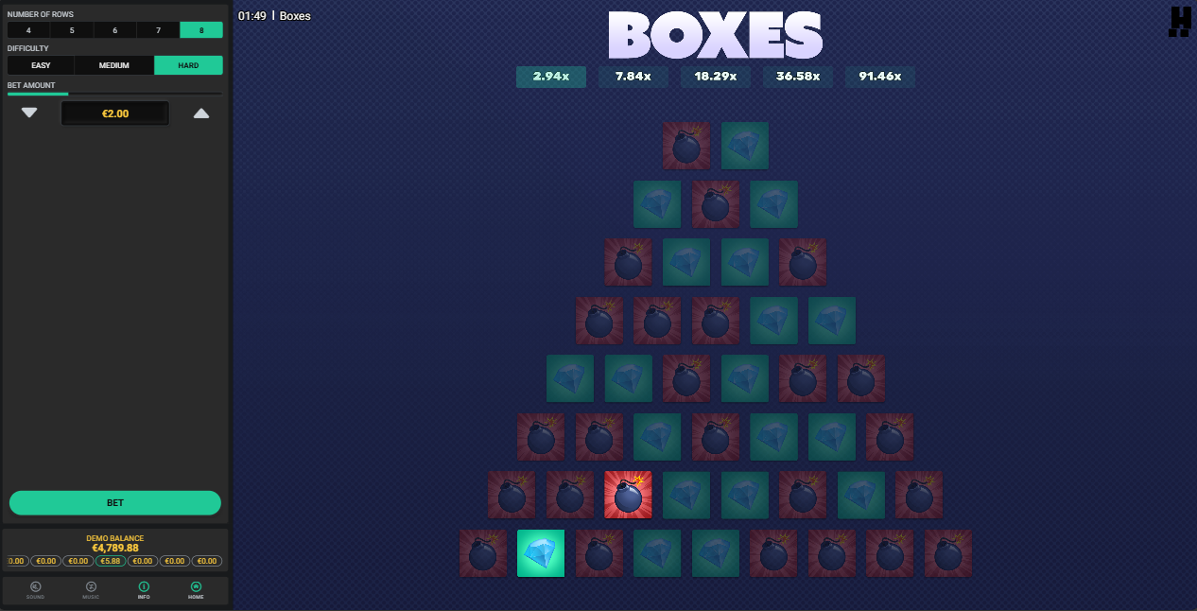

### Sample 2: 8 – Hard

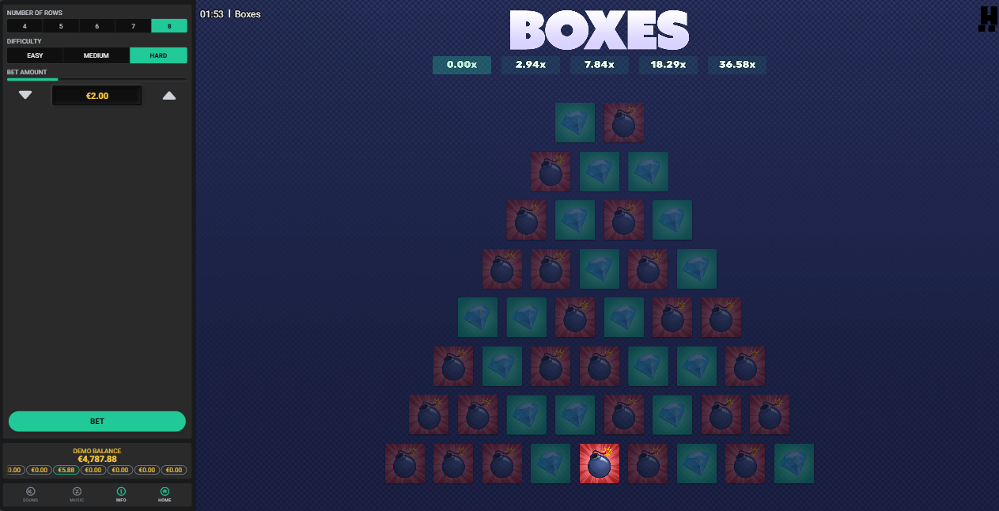

### Sample 3: 8 – Hard

### Conclusion

|  |  |  |
| --- | --- | --- |
| **Easy** | **Medium** | **Hard** |
| 4/9 | 5/9 | 6/9 |
| 3/8 | 4/8 | 5/8 |
| 2/7 | 3/7 | 4/7 |
| 2/6 | 3/6 | 3/6 |
| 2/5 | 2/5 | 3/5 |
| 1/4 | 2/4 | 2/4 |
| 1/3 | 1/3 | 1/3 |
| 1/2 | 1/2 | 1/2 |
| **Range:** 25% - 50% | **Range:** 33.3% - 55.6% | **Range:** 33.3% - 66.7% |

#### Conclusion for Easy

|  |  |  |  |  |  |  |  |  |
| --- | --- | --- | --- | --- | --- | --- | --- | --- |
| **Reward** | 1.76 | 2.82 | 3.95 | 5.92 | 9.87 | 13.17 | 19.75 | 39.51 |
| **Bomb** | 4 | 3 | 2 | 2 | 2 | 1 | 1 | 1 |
| **Layer** | 8 | 7 | 6 | 5 | 4 | 3 | 2 | 1 |

#### Conclusion for Medium

|  |  |  |  |  |  |  |  |  |
| --- | --- | --- | --- | --- | --- | --- | --- | --- |
| **Reward** | 2.20 | 4.41 | 7.71 | 15.43 | 25.72 | 51.42 | 77.17 | 154.35 |
| **Bomb** | 5 | 4 | 3 | 3 | 2 | 2 | 1 | 1 |
| **Layer** | 8 | 7 | 6 | 5 | 4 | 3 | 2 | 1 |

#### Conclusion for Hard

|  |  |  |  |  |  |  |  |  |
| --- | --- | --- | --- | --- | --- | --- | --- | --- |
| **Reward** | 2.94 | 7.84 | 18.29 | 36.58 | 91.46 | 182.93 | 274.40 | 548.80 |
| **Bomb** | 6 | 5 | 4 | 3 | 3 | 2 | 1 | 1 |
| **Layer** | 8 | 7 | 6 | 5 | 4 | 3 | 2 | 1 |

Sorry I really couldn’t figure out how this sequence was generated